

PixelProbe

A.I Image Detection System

Project Engineering

Project Proposal

**Naoise O’Loughlin**

**BEng (Hons) in Software & Electronic Engineering**

**Supervised by Dr. Fergus Downey**

**Atlantic Technological University Galway**

**2025/2026**

Project Description

The rapid rise of generative AI tools such as DALL-E, Midjourney and Stable Diffusion has made it increasingly difficult to distinguish synthetic images from real photos. AI systems produced approximately 34 million images per day in 2023 only a year after the release of ChatGPT, with over 15 billion generated by August 2023[1][2]. This surge in fake media presents a growing challenge for media verification, digital forensics and public trust online. The proposed project aims to develop a complete end-to-end system that classifies images as either AI-generated or authentic using a customized MobileNetV2 model trained in TensorFlow.

The system consists of three main components: a REST API backend for model inference, a database to store historic data, and a React based web application for user interactions. Users will be able to upload unseen images, receive prediction results alongside confidence scores, and access the history of previous predictions. This modular project design allows scalability, maintainability and ease of integration with future features such as user feedback.

The core of the system is based on a customized version of MobileNetV2, adapted to enhance the model's sensitivity to subtle artifacts commonly found within AI-generated content, these include unnatural textures, inconsistent lighting and anatomical anomalies. These features may be imperceptible to the human eye but detectable through fine-tuned convolutional layers. The model will be optimized for low-latency inference, making it suitable for real-time applications without sacrificing accuracy or generalization across multiple image generation methods.

Key challenges will include organizing a balanced and mixed dataset of real and generated images, allowing cross-model generalization and optimizing backend performance for consistent predictions. Additional challenges may include fine tuning the MobileNetV2 model to detect subtle visual anomalies and keeping consistent inference speed across varied image inputs. The chosen database will need to be designed to handle logging of predictions, timestamps and confidence scores, while the front end must be responsive and intuitive across devices.

This project addresses not only a pressing issue in modern day technology but also contributes to the broader conversation about AI ethics. By combining machine learning, web development and scalable UX design, the system aims to help users assess the origins of visual media in an increasingly AI-powered online environment.

Architecture Diagram

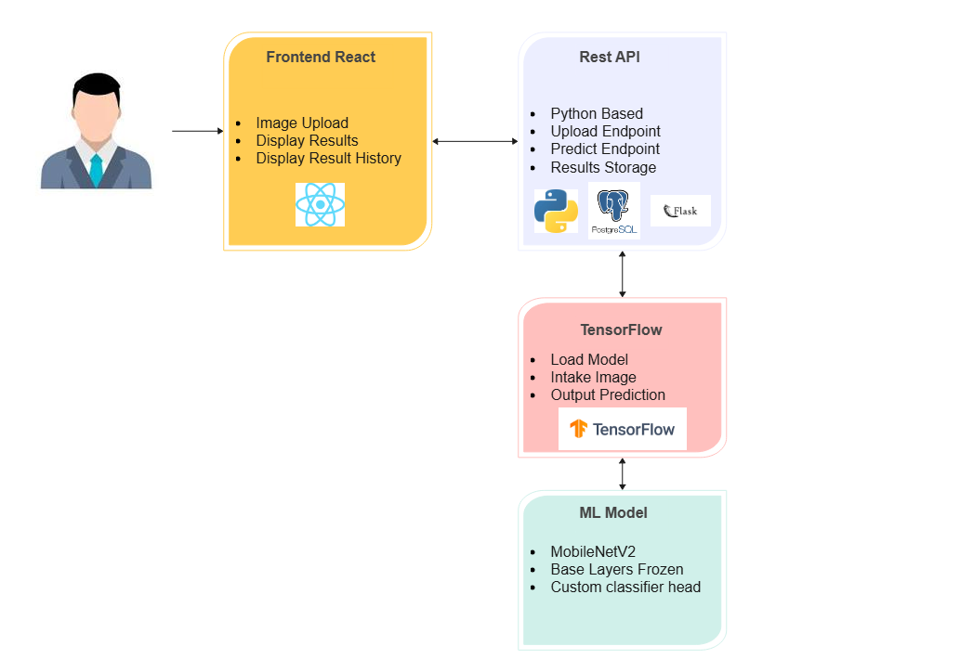

Software Required

**Python:** Core programming language for backend, machine learning & model training

**TensorFlow:** Deep learning framework used to train and fine-tune the customized model.

**MobileNetV2:** Lightweight convolutional neural network architecture optimized for image classification and handling client requests.

**REST API:** Interface layer for serving model predictions and handling client-server communications.

**PostgreSQL:** Relational database system for storing prediction history, timestamps and confidence scores.

**React:** JavaScript library for building responsive and interactive web applications.

**JSX:** Syntax extension for JavaScript used within React.

**React Native:** Framework for building cross-platform mobile applications, enabling future scalability to mobile devices.

Timeline

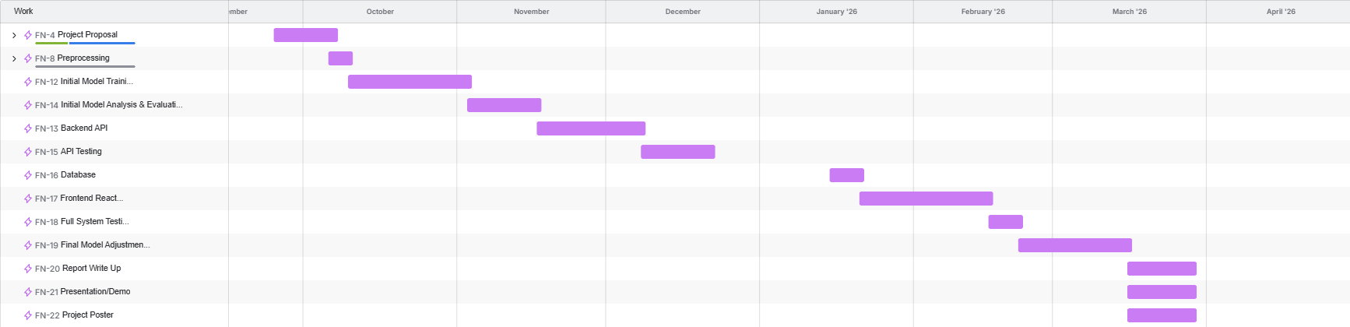

References

[1] MarketingProfs. (2023). Surge of AI-generated images online. [Online] https://www.marketingprofs.com/charts/2023/49890/surge-of-ai-generated-images-online

[2] EveryPixel. (2023). AI image statistics: How many images online are generated by AI? Everypixel Journal. https://journal.everypixel.com/ai-image-statistics